Minutes of the Committee Meeting 1st August 2016

Present: Nathan Scott Chairman
Andy Reid Secretary
Chris Green Treasurer
Dave Debnam Vice President
Paul Davies Men’s Captain
Lorraine Webb Ladies Captain
Andy Ward
Thom Darby
Helen Morris

1 Chairman’s Comments
Chairman’s report July 2016
Can you believe that July is over and done with already? It seems not a week ago I was writing out the comments for June but it does seemed to have zipped by.
Congratulations to all those who have raced throughout the month. Having read through the Captains report I can see that there has been a huge number of PB’s obtained but I will leave the plaudits for the race report.
This month in my comments I wanted to focus on the beginners. Firstly I want to thank all the coaches who got involved this year for all their time and effort. I think we can safely say it has been a lot of fun and an overwhelming success. I appreciate everything you have done to support the beginners throughout the 12 weeks of the course.
Secondly, thanks must go to all the helpers that have assisted the coaches over the 12 weeks. Whether you assisted once or every week I know that the course wouldn’t have been as successful without you to rely on.
Finally and in my view most importantly, I want to congratulate and thank the beginners. At the beginning of the 12 week course many had trouble in running for 1 minute on that dull cold evening on the common. Fast forward to 23rd July and the remaining beginners all completed their goals of running the Luton Parkrun – in very different weather conditions! Superb achievement and I am proud of each and every one of you that made it through the 12 weeks. The ultimate hope now is that we see a high number of those beginners join as members and integrate into the club, this is where I ask for everyone’s help.
I’m sure we all remember being new to the club or indeed to running and how daunting it is to try and find people to run with. Of course some people are more daunting to approach than others! As members can I ask that all of you make an additional effort on club nights to introduce yourself to the new faces, find out a little something about them and see if you can take them for a little run or invite them to run with your usual group. Although the coaches will continue to offer additional support for the newbies we rely on you to make everyone feel welcome and to enjoy their time at Striders.
My final ask is that if you have not already done so, please enter the Striders race planned for 16th October. We really need to fill those 300 places so please spread the word far and wide – it is the main reason for my sleepless nights recently. Thank you
Nathan

2 Apologies
Apologies were received from Zena Ellis, Miriam Linforth and Ashley Philpott

3 Previous Minutes
The minutes for July were accepted.

4 Matters Arising
We will be closing the entrys for the Alf Brown Race next Thursday.
Entrys are needed for the Striders race.

5 Secretary Report
Correspondence received:
Invitation to the Fairlands Valley Relays
Coach visits for Disabled athletes available
3A’s committee meeting cancelled again
Sports Tours International advert
Beds & Luton Schools Championships to be held
Saffron Striders Multiterrain 10K on the 25th September
Leighton Fun Runners Weary Soles relays announced
Mark Sains is now changing club to Guildford & Godalming AC

6 Treasurer’s Report
CG reports
Cash held £254
Bank account £7267
Charity money £1515

Running Report
Running Report by Lorraine Webb & Paul Davies for July 2016
Wow, what an amazing, totally awe inspiring month ! Our Beginners continued to thrive and achieve things that seemed out of reach only 12 weeks ago. Many have now seen first-hand the wonder of parkrun and its unbeatable community spirit. A fabulous 28 took part in the Graduation parkrun in rather warm conditions and smashed it – so WELL DONE !!! We now look forward to welcoming our Beginners as fully fledged members and help integrate them into our Club. The weather has been temperamental to say the least, from torrential rain and flooding to hotter than Hawaii !!! On my first attempt this year at Dog Leg Hill ( Cardiac’s middle sister ), I discovered those pesky horseflies are already out in force so if you’re heading across the fields, be generous with the insect repellent as I am reliably informed that eating copious amounts of marmite & garlic do not keep them at bay !
Our forthcoming race is creeping closer and closer so please, do whatever you can to promote it. It’s your race too ! Don’t forget, if you graduated from our Beginners Course, you get free entry, please refer to your Welcome Letter for the details.
2nd & 3rd July
An exact 50/50 split across 26 of our regulars and beginners completed the Luton parkrun this morning. John Chapman was the first Strider across the line in 20:27. Both Ian Pitkin & Tony Burrows ran their 1st resulting in PBs of 25:01 & 43:12 respectively. An amazing 9 of our beginners obtained PBs: Sonia Blackett (30:22), Lisa French (30:40), Meriel Ascott (34:07), Iain Mose (1st time, 34:55), Jacky Richardson (35:07), Abigail Bruce (35:34), Becky Shotbolt (36:50), Janine Blackett (36:50), Richard Eaves (1st time, 37:14) & Kathleen Hayhurst (43:47).

parkrun tourists:
- Bedford - Paul Davies (19:11), Graham Busch (23:44) & Lorraine Webb (25:43).
- Folkestone - Amanda Rankin (31:23).
- Oak Hill, East Barnet - Mark Layzell (32:45).
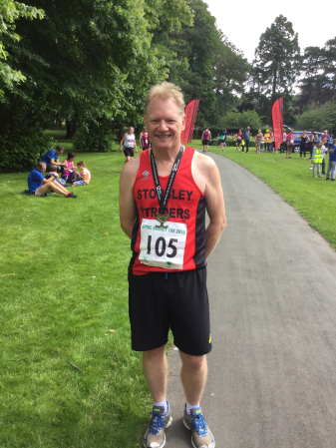
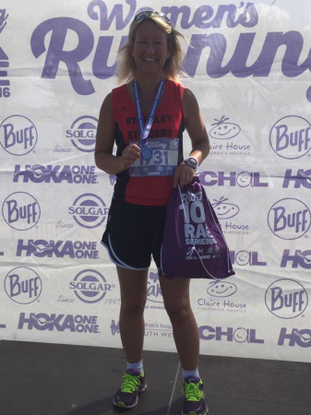
Andy Smith, returning from injury completed the Enigma Need for Speed Marathon in a time of 4:31:52.

A rather warm Sunday saw Andy Durrant toddle off quietly
to Watford to run the Spire Bushey 10K and finish in
46:49, Valerie Dawson drove the opposite way up the M1
and ran the Women’s Running 10k at Milton Keynes in a
time of 58:51 and Martin Smith completed the
Bassingbourn Half in a time of 2:13:41.

22 of our Striders ran in the Luton AC Series 5k at Wardown. Christine Lathwell finished 1st female overall female in 19:20 and was followed by Adrian Copp (19:25), Gez Fallon (19:28), Pat Blessing took an amazing 14 seconds off his previous 5K PB, finishing in 20:05, Martin Fallon (20:43 PB), Linda Scanlan (20:59 & 1st V35), Liz Rollinson (21:55), Thom Darby (22:10), Philip Davies (22:17), Paul Keech (22:38), Vanessa Thompson (23:46), Dave Thompson (25:15), Simon Cain (25:33), Kelvin Chadwick (27:09), Dave Browne (27:21), Terry Willis (27:38), Kate Neale (28:58), Maria Petts (29:19), Donna Wiggett (32:52), Penny Kilbey (35:55), Tommy Murphy (37:00) and Jim McIntosh (45:47).
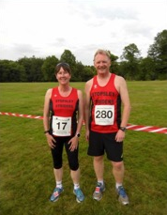
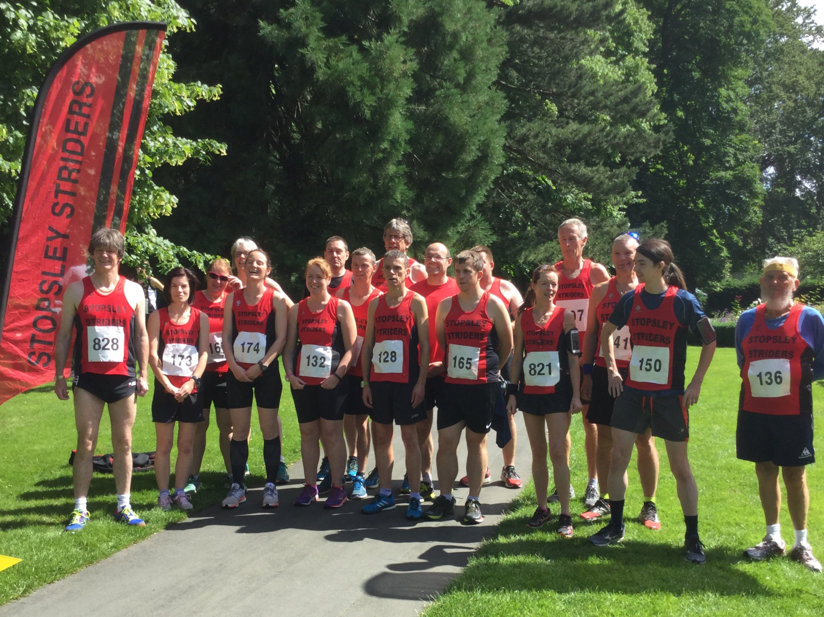
7th, 8th, 9th & 10th July

Thursday saw Andy Durrant & Amanda Rankin run the Hatfield 5m. Andy gained himself
a nice new PB of 36:35 and Amanda finished in 51:08. Well done peeps.

Thursday also saw Christine Lathwell running the 10,000m track race in Sandy in under 40mins which secured her place as EVAC Champion V35 and Beds Champion V35. Nicely done as she had a special birthday to then look forward to and celebrate.
18 of our Striders & 9 of our Beginners completed the Luton parkrun. Pat Blessing led the Striders home in 20:06 and gained himself a new PB. PBs were also gained by Alan Barry (20:57), Derek Christopher also obtained the Club V65 record in (23:29), Christina Green (24:13), Lisa Perrins (26:02), Jacky Richardson (34:43), Amrik Singh (1st time, 26:51), Nora Allsopp (1st time, 39:44), Pauline Moran (39:52), Bimla Assra (40:14), and Ann Compton (40:15).
parkrun tourists:
- Kingston - Mark Layzell (30:41).
- Orpington - Ellie Ballinger (27:20).
- Poole - Philip Davies (22:20) & Brian Davies (24:04).
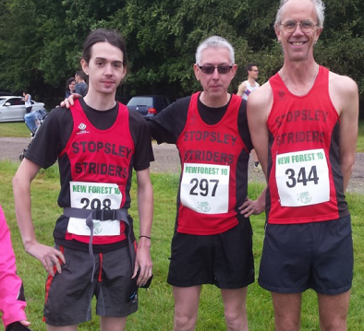
Sunday saw 3 Striders taking part in the New Forest 10m. John Chapman crossed the line first in 1:07:03 and was 1st Vet 55 and was followed by Philip Davies (1:18:02 PB) by 13 minutes and Brian Davies (1:21:58).

Nathan Scott took part in The Gauntlet Half Iron Triathlon at Hever Castle in Kent. I’m sure Nathan will agree that reading the race brief beforehand would have served him well, as apparently he not only took the wrong bike, he took the wrong terrain shoes ( I find running in heels quite difficult too, so you’re not alone ). Determined not to let these “little” factors deter him, he dug deep and conquered the course in a superb time of 5:40:27. Luckily, he will be well briefed for when he returns in September ( although it’s probably wise to check they don’t change the course beforehand… ).
Also taking part in the Hever Castle Aquabike race was Andy Ward who finished in a time of 3:53:40.
Weekend of 16th & 17th July
Wow, we saw a lot of parkrun activity this week and parkrun tourism seems to be becoming increasingly more popular. I’ll start with the usual Wardown results first. John Chapman was the first Strider home in 20:35. Parkrun PBs this week were gained by our beginners Kat Tuloo (30:29), Amrik Singh (33:46), Alison Howe (34:58), Pauline Moran (39:31), Ann Compton (39:36) and Bimla Assra (40:09).
parkrun tourists this week:
- Burnham & Highbridge - Kim Caddy (35:28).
- St Albans - Ellie Ballinger (25:42).
- Southwark - Mark Layzell (31:24).
- Rushmere - Christina Green (27:23), Lorraine Webb (28:58) & Carla Greer in (41:52).
- Worthing - Kate Neale (29:07).
Stewart Reed & Liz Davies completed the Ashridge Half Marathon with Stewart finishing in a time of 2:24:10 and Liz finished in 2:24:44.
A scorcher of a Sunday saw an amazing 27 Striders taking part in the final race in the Luton AC Series. The 10K route saw Gez Fallon being our first Strider home in 41:22 ( even you can’t say the course is flat Gez !!! ). Christine Lathwell followed closely behind and was 1st Lady home in 42:31, not only that, she won the overall Series title ! Next up was Chris Green (43:50), Pat Blessing (44:16), Linda Scanlan (45:21 1st Lady Vet & 3rd in the overall Series ), Liz Rollinson (46:15 & 1st Lady Vet 45), Thom Darby (48:29), Philip Davies (48:44), Brian Davies (51:15), Phil Nitchen “aka the man with the amazing sprint finish” (52:15), Dani Gibson (54:12), Hannah Fothergill (54:45), Nick Crane (55:42), Tony Riley (56:27), Jenny Cottam (57:02 PB), Ellie Ballinger (57:44), Martin Smith (59:29), Simon Cain (1:00:34), Carly Eaves (1:00:53), Kelvin Chadwick (1:01:38), Terry Willis (1:02:07), Dave Brown (1:02:25), Maria Petts (1:07:12), Donna Wiggett (1:11:25), PJ Hough (1:14:43 & 1st V75), Tommy Murphy (1:19:30) and Jim McIntosh (1:43:06 & 1st V80). Linda Scanlan, Liz Rollinson & Dani Gibson also won 1st Ladies Team – go ladies !!
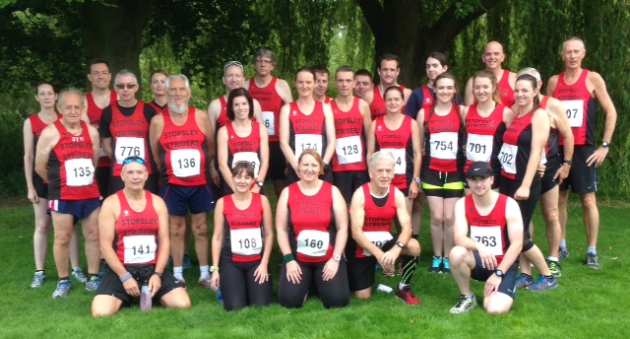

Not content with just winning in the morning, Christine Lathwell then travelled up to Solihull, West Midlands and took part in the Solihull 3000M and finished in a time of 11:20 and came 3rd overall. Time to put those feet up Christine !!
6 Striders took part in the Great Newham London Run 10K. Andy Reid completed the course in 45:24, Valerie Dawson (1:01:34), Judy Reid (1:03:20), Phil Abbitt (1:04:20), Pam Abbitt (1:14:11) and Gill McLaren finished in (1:14:11).
Amanda Rankin took part in the Keech Colour Dash 5K.
Rob Barnes came 2nd in a field of 35 in the Fairlands Valley Challenge and completed the 50k course in 4:37:17.
21st, 23rd & 24th July
Amanda Rankin took part in the Panshanger 5M and finished in 57:36.
As this week’s Luton parkrun was our Beginners’ Graduation, all recorded times are shown below this week, not just our first Strider home and any pbs obtained.
Our Beginners sealed their 12 week course by completing the Luton Wardown parkrun. 1st Strider and 1st overall was Rob Barnes (17:58), he was followed by Gez Fallon (19:33), John Chapman (19:52), Alan Barry (20:22 PB), Philip Davies (21:00 PB), Linda Scanlan (21:54), Andy Reid (22:21), Pat Blessing (22:23), Nick Sandle (22:46), Christina Green (23:34 PB), Brian Davies (24:14), Stewart Read (24:21), Lee Bearley (24:28 PB), Dave Thompson (24:36), Hannah Fothergill (24:37), Ian Pitkin (25:09), Jenny Cottam (25:24 PB), Ashley Philpott (26:21), Karen Ashby (26:36), Kelvin Chadwick (26:52), Ellie Ballinger (26:58), Valerie Dawson (29:17), Sonia Blackett (27:44 PB), Kat Tuloo (30:00 PB), Simon Norris (30:11), Stacey Hunter (31:10 PB), Liz Davies (31:29), Judy Reid (31:54), Siobhan Jenkins (32:00), Jo-Anne Cummins (32:39 PB), Vanessa Thompson (33:43), Orla Thompson (33:44 PB), Abigail Bruce (34:32 PB), Amrik Singh (34:54), Meriel Ascott (34:58), Alison Howe (35:15), Louise Wright (35:23 PB), Maria Petts (35:23), Janine Blackett (35:33 PB), Rachel Burns (37:01), Tommy Murphy (37:09), Amy Burns (37:13 PB), Karen Bull (38:46 PB), Richard Eaves (39:10), Emily Davey (39:15 PB), Nanette Harries (39:36 PB), Lu Philpott (39:40 PB), Penny Kilbey (40:29), Pauline Moran (40:30), Ann Compton (41:59), Bimla Assra (42:01), Dan Lewis (42:09), Charmaine Williams (42:49), Kate Neale (42:50), Anna Noble (44:09 PB), Claire Bates (45:21 PB), Amanda Rankin (45:22), Cindy Guerin (46:57), Liz Evans (46:58), Zainab Savage (48:48 PB), Gill McLaren (48:51), Sharon Roberts (50:28), Carly Eaves (57:06).
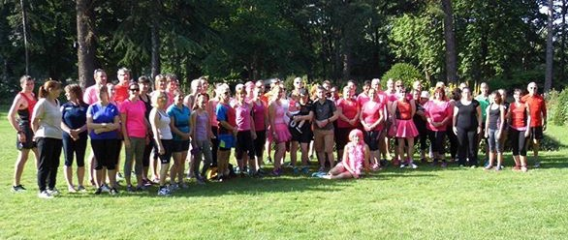
parkrun tourists this week:
- Chippenham - Lorraine Webb (27:26), Willie Ellingham (27:27), Tom Willis (28:06), Terry Willis (31:17) & Zena Ellis (31:24).
- Hampstead Heath - Claire Frost (35:18) & Mark Layzell (35:19).
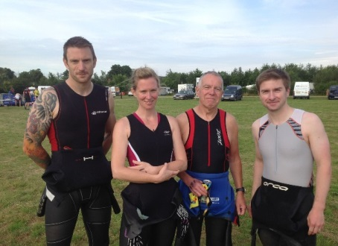
Mark Sains represented Striders at the Elmbridge 10k and finished the course in a PB time of 35:56.
Andy Smith travelled to Bath and finished their Running Festival Marathon in 5:35:53.
Sunday saw Nathan Scott, Chris Green, Andy Ward & Alison Davidson represent
the first ever Striders Team at the Bedfordshire Triathlon Sprint Distance at
Box End. Nathan led the Striders home in 1:07:54, Chris followed in 1:18:05,
Andy 1:35:19 and Alison 1:49:05.
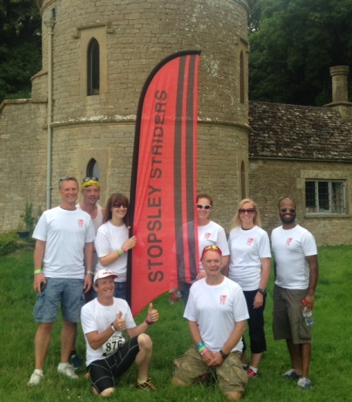

Striders also entered a team in the 100mile Run 24 hour relay in the Cotswolds. Lorraine Webb, Zena Ellis, Tom Willis, Terry Willis, Willie Ellingham, Kim Caddy, Chris Caddy & Niv Sithamparanathan ran 24 laps in less than the allotted time which amounted to 136 miles between them coming 37th out of 135 teams. Great going guys !

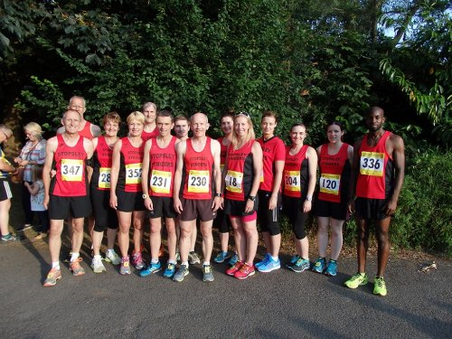
Midweek – 27th & 28th July
A good turnout by our Striders at the Doug Anderson 5K in Bedford on
Wednesday saw John Chapman leading them home in 19:12. John was
followed by Gez Fallon (19:22), Chris Green (19:48), Pat Blessing (20:05),
Karl Tull taking part in his first official race finished in (20:51) – no turning
back now Karl !!, Andy Reid (21:32), Paul Keech (21:54),
Christina Green (23:17 PB), Lorraine Webb (24:50), Ellie Ballinger (25:45 PB),
Karen Ashby (25:48), Carly Eaves (27:10), Judy Reid (29:44),
Claire Frost (31:17 PB) and Mark Layzell (31:42).

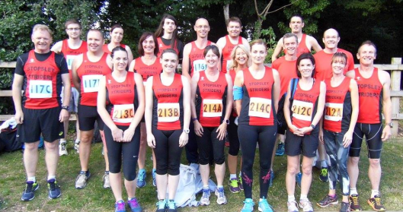
Thursday saw 3 Ladies’ Teams and 2 Men’s Teams enter the Fairland’s Valley Relays in Stevenage. Our Vet Team comprising of Vanessa Thompson, Liz Davies & Liz Rollinson finished 11th in 39:53 (2nd in the County). Christina Green, Ellie Ballinger & Hannah Fothergill made up our Senior Team and finished 22nd in 41:53 (2nd in the County) and our second Senior Team of Amanda Rankin, Valerie Dawson & Carly Eaves finished 40th in 48:01 (7th in the County). Our Senior Men’s Team of Chris Green, Kelvin Chadwick, Alan Barry, Philip Davies & Daniel Mann finished 29th in 61:21 (6th in the County) and our Vet Men’s Team including Adrian Copp, Stewart Read, Andy Durrant, Willie Ellingham & Martin Fallon finished in 33rd place in 63:13 (3rd in the County).
30th & 31st July
The Luton Wardown parkrun saw John Chapman leading the Striders home in 19:43. PBs gained this week by: Daniel Mann (20:48), Philip Davies (20:48), Lee Bearley (23:52), Jenny Cottam (24:36), Alison Howe (33:12), Emily Davey (35:11), Tommy Murphy (36:31), Pauline Moran (39:23) and Lu Philpott (39:26).
parkrun tourists this week included:
- Aylesbury – Lorraine Webb (26:40) & Claire Frost (30:39 PB).
- Falkirk – David Brown (28:06) & Penny Kilbey (36:43).
- Rushmere – Stewart Read (26:50) & Liz Davies (27:46).
- Wimbledon – Mark Layzell (31:57).
- Wolverhampton – Ellie Ballinger (25:24).
The Luton AC Series proved as popular as ever, and on behalf of the Club, I’d like to thank all those who helped with the registration / inputting of results / late entries etc – without you, this Series wouldn’t have been the success it was. So a mahoosive THANK YOU to Elaine Harries & Stuart Harries and also thank you to their little helpers, Christina Green, David Brown, Penny Kilbey, Lorraine Webb & Paul Davies.
Many congratulations to Miriam & Craig who welcomed their beautiful baby girl Lara Daisy into the world on Saturday 9th July. Enjoy the early days of parenthood guys and we look forward to seeing Miriam joining the ranks of the buggy pushers at parkrun very soon... Congratulations also to Andy Ward who became Grandfather to Savannah on 1st July.
Finally, as I finish this report, many of you will be heading off on your summer holidays. Enjoy spending time with your family and/or friends, enjoy one or two extra bottles, I mean glasses of wine but dare I say, don’t forget to pack those trainers ☺.
Remember: Dream. Believe. Achieve.

Alf Brown Race
The closing date is next Thursday. Seven Marshals will be needed.
Nathan will work out the Handicaps.

Striders Race
Up and Running are supplying the numbers with chip incorporated in them.
We need entrants for the race. 150 for each race. Please circulate the flyers.
The medals have been ordered. Goody bags need to be produced.
Bananas may be supplied by Pratts
Andrew Durrant has offered to sponsor some of the costs
St Johns will be in attendance.

Strider of the Month Trophies

Christina Green.

7 Suggestions
None this month

A.O.B.

Paul D. New Members list needed for Paul and Lorraine. AR
Do we need another coach? Yes we do and Carly has agreed to become one.

Park Runs are to be excluded from the club awards from today August 1st 2016

Helen M. Wishes to stop the Birthday Poster in Socials. Agreed

Andy W. None

Lorraine. None

Dave D. None

Thom D. None

Andy R. None

Meeting closed at 9.15pm

Next Meeting to be held in the Barrels on 5th September

